Grade 9

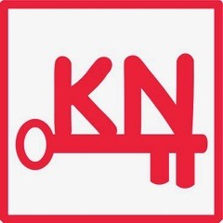

Social Studies Review

(Check your Answers)

Answer Key

1. B 17. False 33. C 49. B

2. False 18. False 34. ** 50. (May vary)

3. True 19. B 35. True

4. True 20. B 36. ***

5. * 21. True 37. True

6. E 22. True 38. (May Vary)

7. F 23. D 39. True

8. A 24. E 40. (May Vary)

9. B 25. A 41. A

10. C 26. B 42. D

11. True 27. A 43. C

12. A 28. True 44. E

13. B 29. B 45. B

14. B 30. C 46. F

15. B 31. B 47. D

16. B 32. B 48. A

**************

**NOTE:**

**\*5) i.** The Guinea area, ii. Maghreb area, iii. Sahel area, iv. The Atlantic area

**\*\*34) i. Ghana ii. Mali iii. Songhai**

**\*\*\*36) i.** Africa ii. Antarctica iii. Asia iv. Australia

v. Europe vi. North America vii. South America